
National College of Ireland
MSc in Artificial Intelligence
Module: Engineering and Evaluating Artificial Intelligence (MSCAI1)
Lecturer: Dr Abdul Razzaq, Dr Abdul Shahid, Sallar Khan
Date of Submission: 26 March 2026

Project Title: Continuous Assessment
Student Name: Enrique Piña Jaime, Dylan Boyle
Student ID: 24218146, 24302911
GitHub Link: https://github.com/Dylanjb96/E-E-AI-CA

Design Choice 1 Implemented Chained Multi-Outputs:
In this design one model family evaluates three chained targets per email instance: Type 2, Type 2 + Type 3 and Type 2 + Type 3 + Type 4. The preprocessing pipeline runs once and the same DatasetBundle is passed to each model implementation through a shared abstract interface. Type 1 is excluded because no classification is required for that column in the provided data.
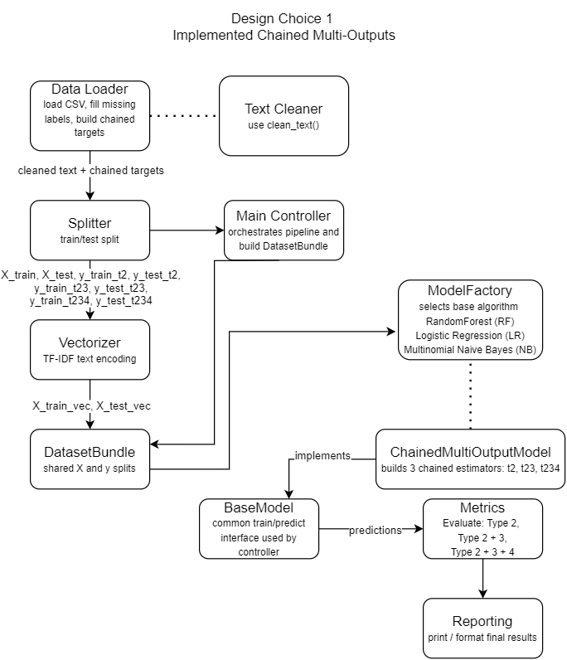

Chained Multi-Outputs Classification Results:
Dataset | Model | Type 2 | Type 2 + Type 3 | Type 2 + Type 3 + Type 4
AppGallery | Random Forest | 0.7917 | 0.6250 | 0.5000
AppGallery | Logistic Regression | 0.7917 | 0.5833 | 0.5000
AppGallery | Multinomial NB | 0.7500 | 0.4583 | 0.3750
Purchasing | Random Forest | 1.0000 | 0.8824 | 0.8824
Purchasing | Logistic Regression | 1.0000 | 0.7059 | 0.7059
Purchasing | Multinomial NB | 1.0000 | 0.7059 | 0.6471
Components Design Choice 1
Component | Type | Responsibility
src/main_controller.py | Controller | Runs the full pipeline: load data, vectorize text, create the DatasetBundle, run the models, and evaluate results
data/Purchasing.csv, data/AppGallery.csv | Data sources | CSV files used as input datasets
src/config.py | Configuration | Defines dataset path, column names, test size, random state, minimum class count, and maximum TF-IDF features
src/preprocessing/data_loader.py | Preprocessing | Loads CSV, applies text cleaning, handles missing labels, and builds chained targets (t2, t23, t234)
src/preprocessing/splitter.py | Preprocessing | Splits the prepared dataset into stratified training and test sets based on Type 2 labels
src/preprocessing/text_cleaner.py | Preprocessing | Provides reusable text cleaning utilities used by the loader
src/features/vectorizer.py | Feature engineering | Fits TF-IDF on training text and transforms train and test sets into numeric matrices
src/data_models/dataset_bundle.py | Data model | Encapsulates X_train, X_test and the three target sets (t2, t23, t234) in a single object
src/models/base_model.py | Abstract interface | Defines the common model API: train(data_bundle) and predict(data_bundle)
src/models/random_forest_model.py | Model implementation | Extends RandomForestClassifier from sklearn. Used by ChainedMultiOutputModel as the underlying classifier
src/models/logistic_regression_model.py | Model implementation | Extends LogisticRegression from sklearn. Used by ChainedMultiOutputModel as the underlying classifier
src/models/multinomial_nb_model.py | Model implementation | Extends MultinomialNB from sklearn. Used by ChainedMultiOutputModel as the underlying classifier
src/evaluation/metrics.py | Evaluation | Computes accuracy for each chained target (t2, t23, t234)
src/evaluation/reporting.py | Reporting | Formats and prints the evaluation results returned by metrics.py
tests/test_pipeline.py | Testing | Smoke test that verifies dataset loading, chained target creation and train/test splitting
tests/test_model_predictions.py | Testing | Verifies that the selected model can train and predict t2, t23 and t234 outputs with the expected prediction keys and lengths
tests/test_targets.py | Testing | Verifies that chained targets target_t2, target_t23 and target_t234 are created correctly from the dataset
src/models/chained_multioutput_model.py | Model strategy | Implements BaseModel. Wraps any sklearn classifier and trains three instances, one per chained target (t2, t23, t234)
src/models/model_factory.py | Factory | Returns the appropriate ChainedMultiOutputModel instance based on MODEL_NAME defined in config.py
Connectors Design Choice 1
Connector | From | To | Description
load and prepare data | main_controller.py | data_loader.py | Controller calls load_dataset() to read and prepare the data
split dataset | main_controller.py | splitter.py | Controller calls split_dataset() to create stratified training and test sets based on Type 2 labels
clean text | data_loader.py | text_cleaner.py | Loader calls clean_text() to normalize raw email text
TF-IDF transform | main_controller.py | vectorizer.py | Controller calls vectorize_text() to fit on training text and transform train/test sets
build bundle | main_controller.py | dataset_bundle.py | Controller packages features and targets into a DatasetBundle object
train and predict | main_controller.py | model instances | Controller calls get_model() from model_factory.py which returns the appropriate ChainedMultiOutputModel, then calls train(data_bundle) and predict(data_bundle) through the BaseModel interface
predictions | model instances | metrics.py | Prediction dictionaries (keys: t2, t23, t234) are passed to evaluate_predictions()
evaluation output | metrics.py | reporting.py | Accuracy results are passed to print_evaluation() in reporting.py which formats and prints them to the console
pipeline test | test_pipeline.py | pipeline modules | Smoke test checks dataset loading, chained target creation, and train/test splitting in the base pipeline

Data Elements Design Choice 1
Data Element | Type | Description
Interaction content | text | Primary email text field used as model input
Type 2 / Type 3 / Type 4 | categorical labels | Dependent label columns used to form chained targets
target_t2 | string/categorical | Chained target containing Type 2 only
target_t23 | string/categorical | Chained target combining Type 2 and Type 3
target_t234 | string/categorical | Chained target combining Type 2, Type 3 and Type 4
X_train / X_test | text collections | Training and test text prior to vectorization
X_train_vec / X_test_vec | numeric matrices | TF-IDF feature matrices produced by the vectorizer
y_train_t2 / y_test_t2 | label arrays | Train/test labels for target_t2
y_train_t23 / y_test_t23 | label arrays | Train/test labels for target_t23
y_train_t234 / y_test_t234 | label arrays | Train/test labels for target_t234
DatasetBundle | Python object | Encapsulated container carrying X and y splits for the pipeline
predictions | dict/arrays | Predicted labels for t2, t23 and t234 returned by the model
accuracy metrics | floats | t2_accuracy, t23_accuracy, t234_accuracy

Design Choice 2 Proposed Hierarchical Modelling:
In this design, model instances are chained by level rather than outputs. A Level 1 model predicts Type 2 on the full dataset. Its predictions are used to filter the data into class-specific subsets, and a dedicated Level 2 model is trained on each subset to predict Type 3. The process repeats for Type 4 at Level 3, resulting in multiple model instances whose count scales with the number of classes at each preceding level.
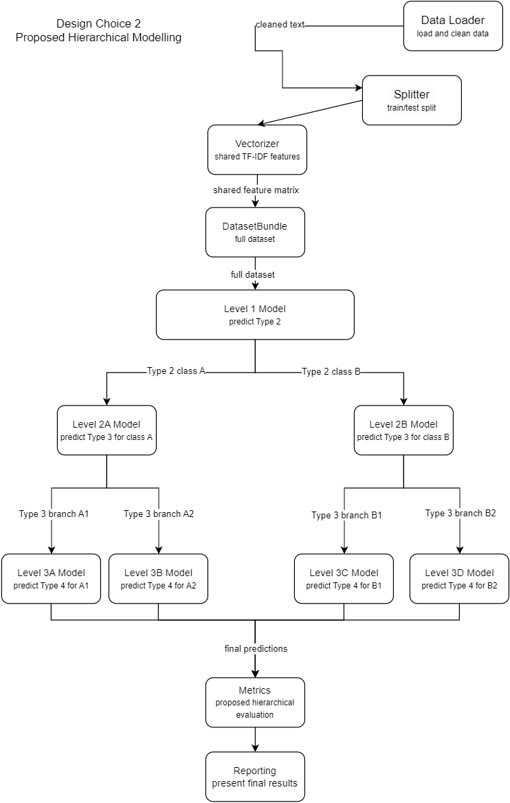

Components Design Choice 2
Component | Type | Responsibility
src/main_controller.py | Controller | Proposed controller for a hierarchical pipeline: would prepare data, create shared features, run Level 1, create branches and evaluate results
data/Purchasing.csv, data/AppGallery.csv | Data sources | CSV files used as input datasets
src/config.py | Configuration | Defines dataset path, column names, test size, random state, minimum class count and maximum TF-IDF features
src/preprocessing/data_loader.py | Preprocessing | Loads CSV, applies text cleaning, handles missing labels and prepares Type 2, Type 3 and Type 4 labels for hierarchical classification
src/preprocessing/splitter.py | Preprocessing | Splits the prepared dataset into stratified training and test sets, reused by the hierarchical pipeline
src/preprocessing/text_cleaner.py | Preprocessing | Provides reusable text cleaning utilities used by the loader
src/features/vectorizer.py | Feature engineering | Creates a shared TF-IDF representation used by all hierarchy levels
src/data_models/dataset_bundle.py | Data model | Full DatasetBundle for Level 1 filtered DatasetBundle instances per branch for Level 2 and Level 3
src/models/base_model.py | Abstract interface | Common train/predict API used by all hierarchy-level model instances
src/models/random_forest_model.py | Model implementation | Classifier implementation that could be instantiated at Level 1, Level 2 or Level 3 in the proposed hierarchy
src/models/logistic_regression_model.py | Model implementation | Classifier implementation that could be instantiated at Level 1, Level 2 or Level 3 in the proposed hierarchy
src/models/multinomial_nb_model.py | Model implementation | Classifier implementation that could be instantiated at Level 1, Level 2, or Level 3 in the proposed hierarchy
src/evaluation/metrics.py | Evaluation | Computes per-level and end-to-end evaluation metrics for the hierarchy
tests/test_pipeline.py | Testing | Base pipeline smoke test reused as a foundation for the proposed hierarchical architecture
src/models/model_factory.py | Factory | Proposed factory/selection logic that would choose or create the classifier instance(s) used at each hierarchy level
Connectors Design Choice 2
Connector | From | To | Description
load and prepare data | main_controller.py | data_loader.py | Proposed controller loads the dataset and prepares the labels for hierarchical classification.
clean text | data_loader.py | text_cleaner.py | Loader calls clean_text() to normalize raw email text before feature generation.
TF-IDF transform | main_controller.py | vectorizer.py | Controller calls vectorize_text() to create a shared TF-IDF representation for all hierarchy levels.
build base bundle | main_controller.py | dataset_bundle.py | Controller packages the full feature matrix and labels into a base DatasetBundle for Level 1.
level 1 classification | dataset_bundle.py | Level 1 model | The full dataset is passed to the Level 1 model to predict Type 2.
filter by Type 2 class | Level 1 predictions | Level 2 models | Predicted Type 2 classes are used to create class-specific subsets for Level 2 Type 3 models.
filter by Type 3 branch | Level 2 predictions | Level 3 models | Predicted Type 3 branches are used to create filtered subsets for Level 3 Type 4 models.
final predictions | Level 3 models | metrics.py | Final branch predictions are collected and passed to the evaluation component.
evaluation output | metrics.py | console output | Proposed hierarchical evaluation reports performance by level and overall hierarchy.

Data Elements Design Choice 2
Data Element | Type | Description
Interaction content | text | Same primary input field as DC1.
Type 2 / Type 3 / Type 4 | categorical labels | Separate labels used at Levels 1, 2 and 3 respectively.
Shared feature matrix | numeric matrix | Single TF-IDF representation used by all hierarchy levels.
Type 2 subsets | filtered datasets | Partitions of the data created per Type 2 class for Level 2.
(Type 2, Type 3) subsets | filtered datasets | Partitions created per (Type 2, Type 3) branch for Level 3.
Level 1 predictions | label arrays | Predicted Type 2 labels.
Level 2 predictions | label arrays | Predicted Type 3 labels per Type 2 branch.
Level 3 predictions | label arrays | Predicted Type 4 labels per (Type 2, Type 3) branch.
Per-level and end-to-end metrics | floats/dicts | Accuracy computed per level and for the overall hierarchy.

